

LAB MID TERM

**CSE2011 – DATA STRUCTURES AND ALGORITHMS LAB**



**(B.Tech. CSE Specialisation in Bioinformatics)**

**WINTER SEMESTER 2020-2021**

|  |  |
| --- | --- |
| **Name:** | ALOK MATHUR |
| **Reg. No:** | 20BCB0086 |
| **Slot:** | L51+L52 |
| **Faculty Name:** | SRIVANI A Ma’am |

**VIT – A Place to Learn; A Chance to Grow**

**Q1)**Write a program to implement LIFO data structure removing duplicate elements while entering using static implementation.

**CODE**

*#include* <iostream>

using namespace std;

int stack[100], top = -1, MAXSIZE, choice;

bool isEmpty();

bool isFull();

bool duplicateFound(int);

void pop();

void push();

void displayStack();

int main()

{

    cout << "Enter number of elements in stack ? " << endl;

    cin >> MAXSIZE;

    cout << "******************************" << endl;

    cout << "1. PUSH" << endl

         << "2. POP" << endl

         << "3. DISPLAY" << endl

         << "4. EXIT" << endl;

    cout << "******************************" << endl;

*while* (choice != 4)

    {

        cout << "Enter your choice ? " << endl;

        cin >> choice;

*switch* (choice)

        {

*case* 1:

            push();

*break*;

*case* 2:

            pop();

*break*;

*case* 3:

            displayStack();

*break*;

*case* 4:

            cout << "Exiting..." << endl;

*break*;

*default*:

            cout << "Invalid choice!!" << endl;

        }

    }

*return* 0;

}

bool isEmpty()

{

*if* (top == -1)

    {

*return* true;

    }

*else*

    {

*return* false;

    }

}

bool isFull()

{

*if* (top == MAXSIZE - 1)

    {

*return* true;

    }

*else*

    {

*return* false;

    }

}

bool duplicateFound(int x)

{

*for* (int i = top; i >= 0; i--)

    {

*if* (stack[i] == x)

        {

*return* true;

        }

    }

*return* false;

}

void pop()

{

*if* (isEmpty())

    {

        cout << "Stack Underflow" << endl;

    }

*else*

    {

        top = top - 1;

    }

}

void push()

{

    int data;

    cout << "Enter data to be pushed: " << endl;

    cin >> data;

*if* (isFull())

    {

        cout << "Stack Overflow" << endl;

    }

*else* *if* (duplicateFound(data))

    {

        cout << "Duplicate Found, Element not inserted." << endl;

    }

*else*

    {

        top = top + 1;

        stack[top] = data;

        cout << "Element inserted Successfully!!" << endl;

    }

}

void displayStack()

{

*if* (isEmpty())

    {

        cout << "Nothing to Display, Stack is empty" << endl;

    }

*else*

    {

        cout << "Elements of Stack->" << endl;

*for* (int i = top; i >= 0; i--)

        {

            cout << stack[i] << endl;

        }

    }

}

**OUTPUT IN TEXT FORMAT**

Windows PowerShell

Copyright (C) Microsoft Corporation. All rights reserved.

Try the new cross-platform PowerShell https://aka.ms/pscore6

PS E:\VIT Semester\Winter Semester 2020\DSA\Lab\MTT> cd "e:\VIT Semester\Winter Semester 2020\DSA\Lab\MTT\Programs\" ; if ($?) { g++ mttQ1.cpp -o mttQ1 } ; if ($?) { .\mttQ1 }

Enter number of elements in stack ?

5

******************************

1. PUSH

2. POP

3. DISPLAY

4. EXIT

******************************

Enter your choice ?

1

Enter data to be pushed:

6

Element inserted Successfully!!

Enter your choice ?

1

Enter data to be pushed:

6

Duplicate Found, Element not inserted.

Enter your choice ?

3

Elements of Stack->

6

Enter your choice ?

1

Enter data to be pushed:

9

Element inserted Successfully!!

Enter your choice ?

1

Enter data to be pushed:

15

Element inserted Successfully!!

Enter your choice ?

1

Enter data to be pushed:

9

Duplicate Found, Element not inserted.

Enter your choice ?

3

Elements of Stack->

15

9

6

Enter your choice ?

1

Enter data to be pushed:

26

Element inserted Successfully!!

Enter your choice ?

1

Enter data to be pushed:

45

Element inserted Successfully!!

Enter your choice ?

1

Enter data to be pushed:

99

Stack Overflow

Enter your choice ?

2

Enter your choice ?

2

Enter your choice ?

3

Elements of Stack->

15

9

6

Enter your choice ?

4

Exiting...

PS E:\VIT Semester\Winter Semester 2020\DSA\Lab\MTT\Programs>

**OUTPUT IN IMAGE FORMAT**

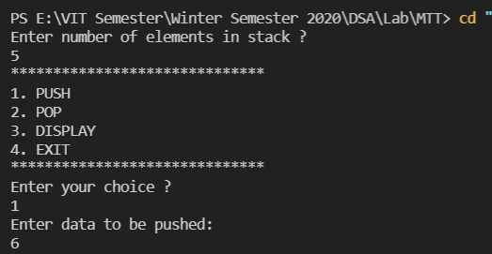

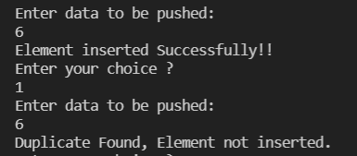  
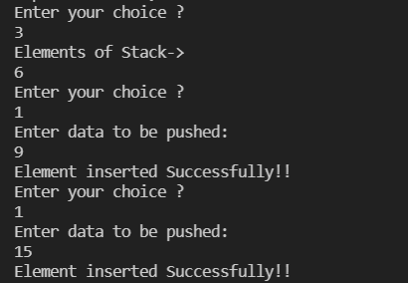  
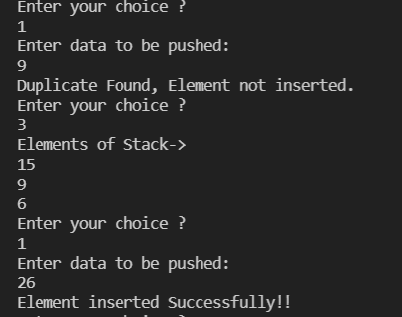

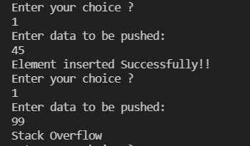

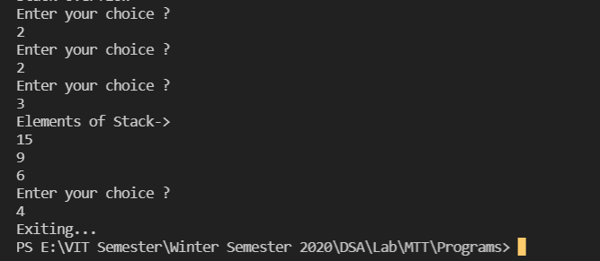

**Q2)** Write a program to perform binary search for an element in a character array.

**CODE**

*// Binary search of an element in character array*

*#include* <stdio.h>

*#include* <iostream>

*#include* <string.h>

*#include* <vector>

using namespace std;

template <class T>

class Searching

{

    T arr[100];

    int n;*// Number of elements in array*

    T search;

public:

    void get()

    {

        int i;

        cout << "Enter the number of elements in array" << endl;

        cin >> n;

        cout << "Enter the elements of array" << endl;

*for* (i = 0; i < n; i++)

        {

            cin >> arr[i];

        }

    }

    int search_in_arr()

    {

        cout << "Enter the element to be searched" << endl;

        cin >> search;

        int midpos;

        int l = 0, h = n - 1;

*while* (l <= h)

        {

            midpos = (l + h) / 2;

*if* (arr[midpos] == search)

            {

                cout << "Element is found at " << midpos + 1 << endl;

*return* 1;

            }

*else* *if* (arr[midpos] > search)

            {

                h = midpos - 1;

            }

*else*

            {

                l = midpos + 1;

            }

        }

*return* 0;

    }

};

int main()

{

    int a;

    Searching<char> s;

    s.get();

    a = s.search_in_arr();

*if* (a == 0)

    {

        cout << "Element not found in array" << endl;

    }

*return* 1;

}

**OUTPUT IN TEXT FORMAT**Windows PowerShell

Copyright (C) Microsoft Corporation. All rights reserved.

Try the new cross-platform PowerShell https://aka.ms/pscore6

PS E:\VIT Semester\Winter Semester 2020\DSA\Lab\MTT> cd "e:\VIT Semester\Winter Semester 2020\DSA\Lab\MTT\" ; if ($?) { g++ mttQ2.cpp -o mttQ2 } ; if ($?) { .\mttQ2 }

Enter the number of elements in array

4

Enter the elements of array

a

b

d

k

Enter the element to be searched

d

Element is found at 3

PS E:\VIT Semester\Winter Semester 2020\DSA\Lab\MTT>

**OUTPUT IN IMAGE FORMAT**

